**How to Connect Printer to WiFi**

### **How to check printer setup on Windows:**

1. Make sure your printer is on, then select Start on your computer.
2. Select Settings > Devices > Printers & scanners.
3. If you don't see your printer listed, select Add a printer or scanner and wait for it to find nearby printers.
4. Select your printer (look for the manufacturer name and model number).
5. Select Add Device and enter the password if required.
6. Finally, make sure your printer is listed in the Printers & scanners section.

### **How to check printer setup on Mac:**

1. Select the Apple® menu at the top-left corner of your computer screen.
2. Select System Preferences > Print & Scan or Printers & Scanners.
3. If you don't see your printer listed, click the + icon, then select your printer from the list.
4. Choose your printer's software or driver in the Use field, and click Add.

## **Connect your printer with a wireless setup wizard:**

If your printer has a touchscreen, you can use its wireless setup wizard tool to connect it to Wi-Fi. Here's how to connect a printer with your wireless settings:

### **How to connect your HP printer to Wi-Fi**

1. Make sure your printer is on and within range of your Wi-Fi network.
2. Tap **Setup**, then tap **Network** or **Wireless Settings**.
3. Select **Wireless Setup Wizard**.
4. Select the Wi-Fi network name and enter your password.

### 

### 

### **How to connect your Epson printer to Wi-Fi:**

1. Make sure your printer is on and within range of your Wi-Fi network.
2. Press the **Home** button on the control panel.
3. Select **Wi-Fi Setup** and press **OK.**
4. Press **OK** until **Wi-Fi Setup Wizard** appears, then press **OK.**
5. Select your Wi-Fi network on the screen, then press **OK**.
6. Enter your password, then press **OK.**
7. You'll see “Setup Complete" on the screen once you're connected.

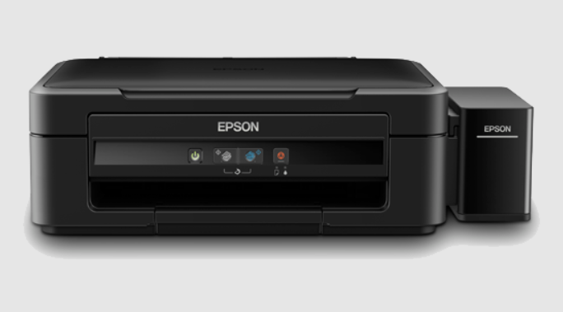

### **How to connect your Canon printer to Wi-Fi:**

1. Make sure the printer is on and within range of your Wi-Fi network.
2. Press the **Home** button on the touchscreen, then press and hold the **Wi-Fi** button.
3. Press the **LAN Wireless setup** button, then press **OK**.
4. Select your Wi-Fi network from the list and enter your network password, then press **OK**.
5. The Power and Wi-Fi light will stop flashing once you're connected.

## **Factory reset your printer:**

To resolve your Wi-Fi issues, you may need to reset your printer's settings. Follow these steps, then try connecting your device to your wireless network. **NOTE**: A factory reset will cause you to lose any manual settings on your printer.

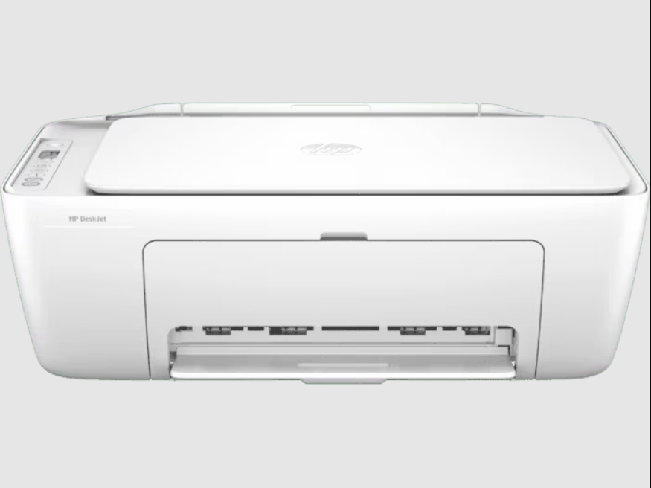

### 

### 

### **How to factory reset your HP printer:**

1. Turn the printer off, then unplug the power cord from the printer for 30 seconds before reconnecting it.
2. Turn the printer on while pressing and holding the **Resume** button for about 20 seconds.
3. Once the Attention light comes on, let go of the Resume button. The Attention and Ready lights will cycle while the printer restores factory settings.



### 

### 

### **How to factory reset your Epson printer:**

1. On the printer's control panel, press the **Home** button, then select **Setup** and press **OK**.
2. Select **Restore Default Settings** and press **OK**.
3. Select **Reset Network Settings** and press **OK**. Then select **Yes** and press **OK**.

### 

### **How to factory reset your Canon printer:**

1. On the touchscreen, select **Setup**.
2. Select **Device settings**, then **OK**.
3. Select **Reset setting**, then press **OK**.
4. Select **Reset all** and press **OK**. Then select **Yes** and press **OK**.

## **Install and update drivers:**

This might sound daunting, but it only takes a few steps.

### **How to install and update drivers on Windows**

1. Go to **Start** > **Settings** > **Devices** > **Printers and scanners**. Under Related Settings, click **Print server properties**.
2. Under **Drivers**, select your printer's driver and click **Remove** > **Remove driver and driver package** > **OK**.
3. Navigate back to the Printer Server Properties window, then select **Drivers** > **Add**. Use the Add Printer Driver Wizard to reinstall your printer driver.

### **How to install and update drivers on Mac**

1. Click the Apple menu at the top left, then select **System Preferences**.
2. Select **Print & Scan** or **Printers & Scanners**, then select the + button at the bottom left.
3. Select your printer, then click the **–** button.
4. Click the **+** button—if you get a pop-up menu, select **Add Printer or Scanner**.